**UNIVERSITY OF MUMBAI**



**Master of Computer Application**

**In-Semester Capstone Project** **Report on**

**DÉCOR HEAVEN**

# Submitted by – Natasha Singh, KaranRaj Singh

**Roll no – 198, 193**

(Semester-I)

# Year 2024-25

Under the Guidance of

Dr. Sonal Sharma

**Table of Contents**

|  |  |
| --- | --- |
| **1. Introduction** | 4-7 |
| Introduction of Project | **4** |
| Project Purpose | **5** |
| Project Objective | **6** |
| Scope of Project | **7** |
| **2. System Study** | **8-11** |
| [Requirement Analysis](https://docs.google.com/document/d/1zWksRN2CQ0wjkqGYrrgwoKcKpXhcKkBGZMbkSeaeF8M/edit#heading=h.1fob9te) | **8** |
| [Planning and Scheduling](https://docs.google.com/document/d/1zWksRN2CQ0wjkqGYrrgwoKcKpXhcKkBGZMbkSeaeF8M/edit#heading=h.3znysh7) | **9** |
| [Preliminary Product Description](https://docs.google.com/document/d/1zWksRN2CQ0wjkqGYrrgwoKcKpXhcKkBGZMbkSeaeF8M/edit#heading=h.2et92p0) | **9** |
| [Justification of Platform](https://docs.google.com/document/d/1zWksRN2CQ0wjkqGYrrgwoKcKpXhcKkBGZMbkSeaeF8M/edit#heading=h.tyjcwt) | **10** |
| [Conceptual Model](https://docs.google.com/document/d/1zWksRN2CQ0wjkqGYrrgwoKcKpXhcKkBGZMbkSeaeF8M/edit#heading=h.3dy6vkm) | **10** |
| **3. Analysis and Design** | **11-21** |
| [Hardware Requirements](https://docs.google.com/document/d/1zWksRN2CQ0wjkqGYrrgwoKcKpXhcKkBGZMbkSeaeF8M/edit#heading=h.1t3h5sf) | **11** |
| [Software Requirements](https://docs.google.com/document/d/1zWksRN2CQ0wjkqGYrrgwoKcKpXhcKkBGZMbkSeaeF8M/edit#heading=h.4d34og8) | **12** |
| [Actual Gantt Chart](https://docs.google.com/document/d/1zWksRN2CQ0wjkqGYrrgwoKcKpXhcKkBGZMbkSeaeF8M/edit#heading=h.2s8eyo1) | **13** |
| [System Design](https://docs.google.com/document/d/1zWksRN2CQ0wjkqGYrrgwoKcKpXhcKkBGZMbkSeaeF8M/edit#heading=h.17dp8vu) | **14** |
| [UML Diagrams](https://docs.google.com/document/d/1zWksRN2CQ0wjkqGYrrgwoKcKpXhcKkBGZMbkSeaeF8M/edit#heading=h.3rdcrjn) | **17** |
| [Flow Chart](https://docs.google.com/document/d/1zWksRN2CQ0wjkqGYrrgwoKcKpXhcKkBGZMbkSeaeF8M/edit#heading=h.26in1rg) | **17** |
| [Data Flow Diagram](https://docs.google.com/document/d/1zWksRN2CQ0wjkqGYrrgwoKcKpXhcKkBGZMbkSeaeF8M/edit#heading=h.lnxbz9) | **18** |
| [Entity Relationship Diagram](https://docs.google.com/document/d/1zWksRN2CQ0wjkqGYrrgwoKcKpXhcKkBGZMbkSeaeF8M/edit#heading=h.35nkun2) | **21** |
| [Description of Entities](https://docs.google.com/document/d/1zWksRN2CQ0wjkqGYrrgwoKcKpXhcKkBGZMbkSeaeF8M/edit#heading=h.1ksv4uv) | **21** |
| **4. Testing and Validation** | **23-26** |
| Code Efficiency | **23** |
| [Testing Approach](https://docs.google.com/document/d/1zWksRN2CQ0wjkqGYrrgwoKcKpXhcKkBGZMbkSeaeF8M/edit#heading=h.44sinio) | **24** |
| [Unit Testing](https://docs.google.com/document/d/1zWksRN2CQ0wjkqGYrrgwoKcKpXhcKkBGZMbkSeaeF8M/edit#heading=h.2jxsxqh) | **25** |
| [Integration Testing](https://docs.google.com/document/d/1zWksRN2CQ0wjkqGYrrgwoKcKpXhcKkBGZMbkSeaeF8M/edit#heading=h.z337ya) | **25** |
| **5.User Manual** | **27-47** |
| User Documentation | **29** |
| Outputs | **31** |
| Code Snippets | **45** |
| **6.Conclusion** | **48-51** |
| Conclusion | **48** |
| Limitations | **49** |
| Future Scope | **50** |

# 1. INTRODUCTION

**Introduction of Project:**

Decor Heaven is an innovative e-commerce platform that revolutionizes the way customers shop for furniture and interior products. Designed to cater to the evolving needs of modern consumers, the platform bridges the gap between traditional in-store shopping and the convenience of digital commerce. It offers a vast and diverse selection of furniture and decor items, ensuring that customers can find products that match their tastes and requirements.

One of the standout features of Decor Heaven is its emphasis on personalization. Customers can tailor their purchases by selecting attributes such as size and color, creating a shopping journey that is both flexible and intuitive. By incorporating advanced technologies like responsive web design, secure payment gateways, and robust administrative tools, Decor Heaven ensures an exceptional experience for both users and administrators.

The platform is designed with scalability and future growth in mind, providing a solid foundation for integrating emerging technologies and expanding its reach. It combines usability with functionality, making it a go-to destination for furniture and interior decor shopping.

**Project Purpose:**

The purpose of Decor Heaven is to serve as a comprehensive platform dedicated to simplifying and enhancing the furniture shopping experience. At its core, the platform aims to achieve the following goals:

1. **Customization and Personalization:** Decor Heaven allows users to tailor furniture and decor items to their needs, enabling customization of size, color, and materials. This feature ensures that each purchase reflects the unique preferences of the customer.
2. **Convenience and Efficiency:** The platform simplifies the shopping process by offering easy navigation, detailed product information, and secure checkout options. Customers can seamlessly manage their orders and track their purchase history.
3. **Secure and Reliable Transactions:** By integrating Stripe for secure payments and providing options like credit/debit cards and cash-on-delivery, Decor Heaven ensures that users feel confident while making transactions.
4. **Comprehensive Administrative Tools:** For administrators, the platform provides tools to manage products, monitor inventory, and generate reports. These features streamline backend operations and enable data-driven decision-making.
5. **Future Scalability:** Decor Heaven is designed to accommodate future growth by integrating advanced technologies, supporting mobile applications, and expanding into global markets with multilingual capabilities.
6. **Enhanced Customer Engagement:** The platform promotes customer satisfaction by offering real-time updates, recommendations. This fosters a strong connection between the platform and its users.

**Project Objective:**

The primary objective of Decor Heaven is to establish a comprehensive and user-friendly platform dedicated to enhancing the furniture shopping experience. By integrating customization, efficient management tools, and secure payment systems, the platform seeks to empower both customers and administrators.

Key objectives include:

1. **Personalization and Customization:** Enable users to customize furniture items by selecting size, color, and material, ensuring products meet their unique preferences.
2. **Simplified Shopping Experience:** Provide an intuitive interface that simplifies product discovery and streamlines the checkout process.
3. **Secure Transactions:** Implement diverse and reliable payment options, including Stripe integration for credit/debit cards and cash-on-delivery services.
4. **Order Management:** Equip users with tools to manage their orders efficiently, offering categorizations for active, completed, and canceled orders.
5. **Administrative Efficiency:** Empower administrators with tools to add products, monitor inventory, generate detailed reports, and manage the platform efficiently.
6. **Scalability and Growth:** Design a platform capable of adapting to future technological advancements, supporting mobile applications, and expanding its user base globally.
7. **Customer Engagement:** Foster user satisfaction through personalized recommendations, real-time updates, and responsive support.

**Scope of the Project**

The Decor Heaven platform addresses a wide range of customer and administrative needs through the following features:

1. **User Features:**
   * Access to a diverse catalog of furniture and decor items.
   * Customization options for size, color, and material selection.
   * Secure payment options, including Stripe and cash-on-delivery.
   * Order management tools to track purchase history and update user details.
2. **Administrative Tools:**
   * Inventory management to monitor and update product availability.
   * Tools for adding and editing product listings.
   * Reporting features to generate and export data for sales analysis and decision-making.
3. **Collaborations and Integrations:**
   * Partnerships with logistics services for real-time delivery tracking.
   * Integration with advanced technologies for scalability and enhanced functionality.
4. **Future Growth Potential:**
   * Multilingual support to cater to a global audience.
   * Mobile applications for seamless shopping experiences on iOS and Android devices.
   * Augmented Reality (AR) features for virtual furniture visualization in customer spaces.
   * Advanced analytics for personalized recommendations and insights into customer behaviour.

# 2. SYSTEM STUDY

**Requirement Analysis:** Requirement analysis involves identifying and documenting the needs of the platform’s stakeholders to ensure a user-centric and effective solution.

1. **Functional Requirements:**
   * Users can browse furniture and decor categories, including customization options for size, color, and material.
   * Secure authentication using Google Sign-In and email/password with OTP-based MFA for first-time users.
   * Integration with Stripe for secure payments, supporting credit/debit cards and cash-on-delivery.
   * Administrative tools for adding products, managing inventory, and generating reports.
2. **Non-Functional Requirements:**
   * High availability and reliability to support users at any time.
   * Scalable architecture to accommodate increasing users.
   * Secure data storage and communication protocols to ensure user privacy.
3. **Technical Requirements:**
   * Frontend built with React and styled with Tailwind CSS for an interactive and responsive interface.
   * Backend developed using Spring Boot for robust API management and business logic.
   * PostgreSQL database for structured and efficient data management.

**Planning and Scheduling:** Effective planning and scheduling are critical to the success of the project.

1. **Phases of Development:**
   * **Requirement Gathering:** Understand user needs and finalize features.
   * **Design:** Create UI/UX wireframes and system architecture.
   * **Development:** Build and integrate the frontend and backend components.
   * **Testing:** Perform functional, performance, and security testing.
   * **Deployment:** Launch the website for public use.
2. **Schedule and Milestones:**
   * **Week 1-2:** Requirement gathering and system design.
   * **Week 3-6:** Development of core functionalities (user interface, customization options, and payment integration).
   * **Week 7-8:** Testing and debugging.
   * **Week 9:** Deployment and final review.

**Preliminary Product Description:** The Decor Heaven platform is designed to provide an enriching shopping experience for customers and robust management tools for administrators.

1. **Key Features:**
   * An expansive catalog of furniture and decor items.
   * Secure payment processing through Stripe.
   * Order management tools for tracking active, completed, and canceled orders.
   * Administrative capabilities for managing inventory and generating reports.
2. **User Interface:**
   * Intuitive design ensuring ease of navigation.
   * Mobile-friendly layout for accessibility across devices.

**Justification of Platform:** The platform’s technology stack is selected based on performance, scalability, and compatibility with project goals.

1. **Frontend (React + Tailwind CSS):**
   * Enables dynamic, responsive, and component-based user interfaces.
   * Ensures a seamless user experience across devices.
2. **Backend (Spring Boot):**
   * Provides robust business logic and RESTful APIs for seamless communication.
   * Supports secure authentication and efficient data handling.
3. **Database (PostgreSQL):**
   * Ensures efficient storage and retrieval of data, including user profiles, product listings, and order details.
   * Supports scalability to handle growing data requirements.

**Conceptual Model:** The conceptual model outlines the system’s structure and user interaction flow.

1. **System Architecture Layers:**
   * **User Interaction Layer:**
     + Frontend built with React for intuitive user interactions.
     + Interfaces for browsing products, customization, and managing orders.
   * **Application Logic Layer:**
     + Spring Boot server manages user requests and processes data.
     + Integration of Stripe for payment functionality.
   * **Data Layer:**
     + PostgreSQL stores user information, product details, and order history securely.
2. **Flow of Interaction:**
   * **User Activities:** Browse products, customize furniture, and place orders.
   * **Server Processing:** Backend logic processes user inputs and interacts with the database.
   * **Admin Oversight:** Admins monitor activity, update inventory, and generate reports.

**3. ANALYSIS AND DESIGN**

**Hardware Requirements:**

**Development Environment:**

* **Processor:** Intel Core i5 or equivalent (minimum), Intel Core i7 or equivalent (recommended).
* **RAM:** 8 GB (minimum), 16 GB (recommended) for smooth multitasking and development tools.
* **Storage:** At least 256 GB SSD for faster read/write speeds and efficient handling of project files.
* **Graphics:** Integrated graphics (sufficient for development purposes).
* **Network:** Stable internet connection for accessing APIs, libraries, and deployment platforms.

**Production Environment (Server):**

* **Processor:** Quad-core CPU (minimum), 8-core CPU (recommended) for handling multiple concurrent user requests.
* **RAM:** 16 GB (minimum), 32 GB (recommended) for better application performance.
* **Storage:** 500 GB SSD (minimum) to store application data, logs, and backups.
* **Bandwidth:** High-speed internet connection to ensure low-latency user interactions.
* **Additional Hardware:**
  + Load balancer for traffic management.
  + Redundant servers for failover and high availability.

**Software Requirements:**

**Development Environment:**

* **Operating System:** Windows 10/11, macOS, or Linux (Ubuntu preferred for deployment).
* **Code Editor:** Visual Studio Code (VS Code) with extensions for React, Spring Boot, and PostgreSQL integration.
* **Version Control:** Git and GitHub for collaborative development.
* **Package Managers:** npm for managing dependencies in the frontend.

**Frontend Development:**

* **Languages and Libraries:** HTML, CSS, JavaScript, React JS.
* **Frameworks:** Tailwind CSS for styling.
* **Browser Tools:** Chrome Developer Tools, React DevTools for debugging.

**Backend Development:**

* **Languages and Frameworks:** Java, Spring Boot.
* **Database Tools:** PostgreSQL for database management.
* **API Testing Tools:** Postman for testing and validating backend APIs.

**Other Tools:**

* **Authentication:** Firebase for Google Sign-In and OTP verification.
* **Payment Gateway:** Stripe for secure payment transactions.
* **Database Management GUI:** pgAdmin for managing and optimizing PostgreSQL queries.
* **Deployment Platforms:** AWS or Heroku for hosting the application.

**Gnatt Chart:**

A Gantt chart is a type of bar chart that illustrates a project schedule. This chart lists the tasks to be performed on the vertical axis, and time intervals on the horizontal axis. The width of the horizontal bars in the graph shows the duration of each activity. Gantt charts illustrate the start and finish dates of the terminal elements and summary elements of a [project.](https://en.wikipedia.org/wiki/Project) Terminal elements and summary elements constitute the [work breakdown structure](https://en.wikipedia.org/wiki/Work_breakdown_structure) of the project. Modern Gantt charts also show the [dependency](https://en.wikipedia.org/wiki/Dependency_(project_management)) (i.e., precedence network) relationships between activities. Gantt charts can be used to show current schedule status using percent-complete shadings and a vertical "TODAY" line as shown here.

Gantt charts are sometimes equated with bar charts.

Gantt charts are usually created initially using an early start time approach, where each task is scheduled to start immediately when its prerequisites are complete. This method maximizes the [float time](https://en.wikipedia.org/wiki/Float_(project_management)) available for all tasks.

**The following represents Gantt chart in tabular form**

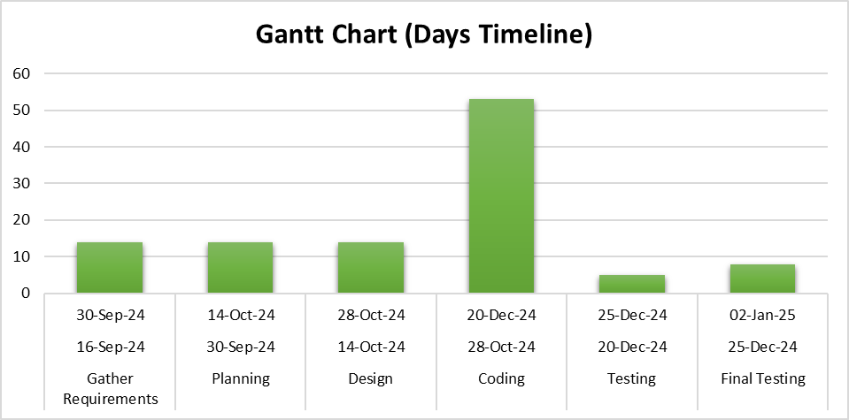

**System Design:**

The system design for the Decor Heaven e-commerce platform includes high-level architecture and detailed design components to facilitate seamless interaction between the frontend, backend, and database, ensuring an optimal user experience and efficient system performance.

**High-Level Architecture**

1. **User Interaction Layer (Frontend):**
   * Built using **React** and **Tailwind CSS** to provide a responsive, modern, and interactive user interface.
   * Facilitates user actions such as browsing products, managing carts, customizing furniture, and updating profiles.
   * Includes secure login and signup functionality via Google Sign-In or email/password with OTP-based MFA for first-time users.
2. **Application Logic Layer (Backend):**
   * Developed using **Spring Boot**, ensuring scalable and modular business logic.
   * Handles API routing, product customization logic, payment processing through Stripe, and profile management.
   * Implements robust security features like authentication, authorization, and input validation.
3. **Data Management Layer (Database):**
   * Powered by **PostgreSQL**, storing structured data like user profiles, product information, and transaction logs.
   * Optimized schemas and indexes ensure efficient retrieval of frequently accessed data, such as product categories and order history.

**Detailed Design Components**

1. **Frontend:**
   * **Components:**
     + Modular React components for login/signup pages, product listings, product customization, cart, payment processing, and profile management.
   * **State Management:**
     + Utilizes React’s Context API or libraries like Redux for efficient state management across the application.
   * **Responsive Design:**
     + Implements Tailwind CSS to ensure cross-device compatibility and a seamless user experience on desktops, tablets, and smartphones.
2. **Backend:**
   * **API Structure:**
     + RESTful API endpoints for user authentication, product browsing, customization, cart management, and order processing.
   * **Middleware:**
     + Spring Boot middleware for request validation, error handling, and session management.
   * **Authentication:**
     + Google OAuth 2.0 and email/password authentication with Multi-Factor Authentication (MFA) using OTP.
   * **Payment Integration:**
     + Stripe API for secure transactions, supporting credit/debit cards and cash-on-delivery options.
3. **Database:**
   * **Data Models:**
     + **User Model:** Stores user credentials, profiles, addresses, and order history.
     + **Product Model:** Captures product details, including categories, size, color, stock availability, and related products.
     + **Order Model:** Maintains details of active, completed, and canceled orders.
   * **Indexes:**
     + Frequently accessed fields like product categories, order status, and user email are indexed for faster query performance.
4. **Integration:**
   * **Frontend-Backend Communication:**
     + Implements asynchronous communication using Fetch API or Axios for efficient data exchanges.
   * **Backend-Database Interaction:**
     + Utilizes JPA (Java Persistence API) with Spring Boot to interact with PostgreSQL, ensuring efficient and secure data management.
5. **Security Measures:**
   * **HTTPS:** Ensures secure communication between the frontend, backend, and database.
   * **Data Encryption:** Sensitive user data, such as passwords and payment information, is encrypted.
   * **Role-Based Access Control (RBAC):** Provides restricted access to admin-specific features like adding products and generating reports.

**UML Diagrams:**

[**Flow Chart:**](https://docs.google.com/document/d/1zWksRN2CQ0wjkqGYrrgwoKcKpXhcKkBGZMbkSeaeF8M/edit#heading=h.26in1rg)

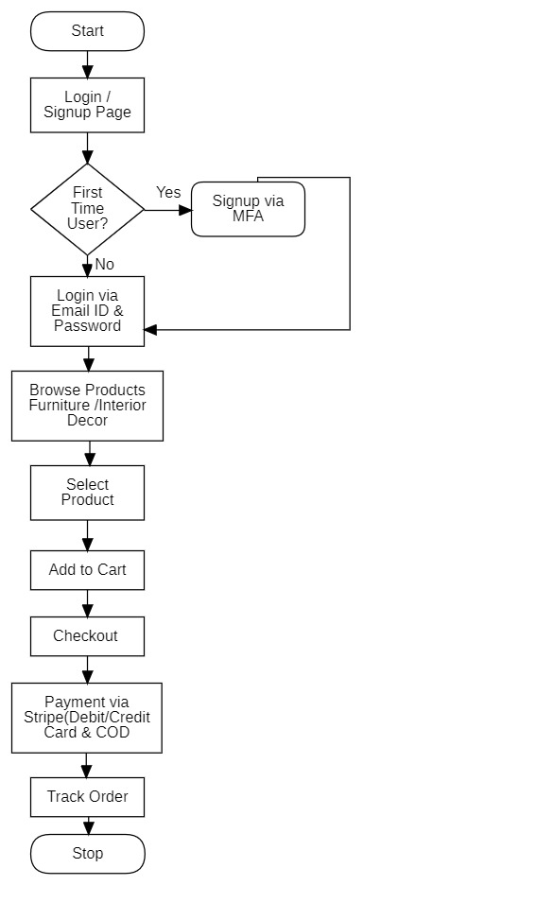

[**Data Flow Diagram:**](https://docs.google.com/document/d/1zWksRN2CQ0wjkqGYrrgwoKcKpXhcKkBGZMbkSeaeF8M/edit#heading=h.lnxbz9)

DFD Level 0:

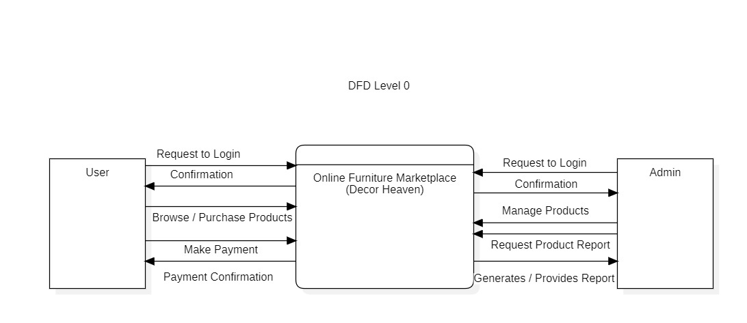

DFD Level 1

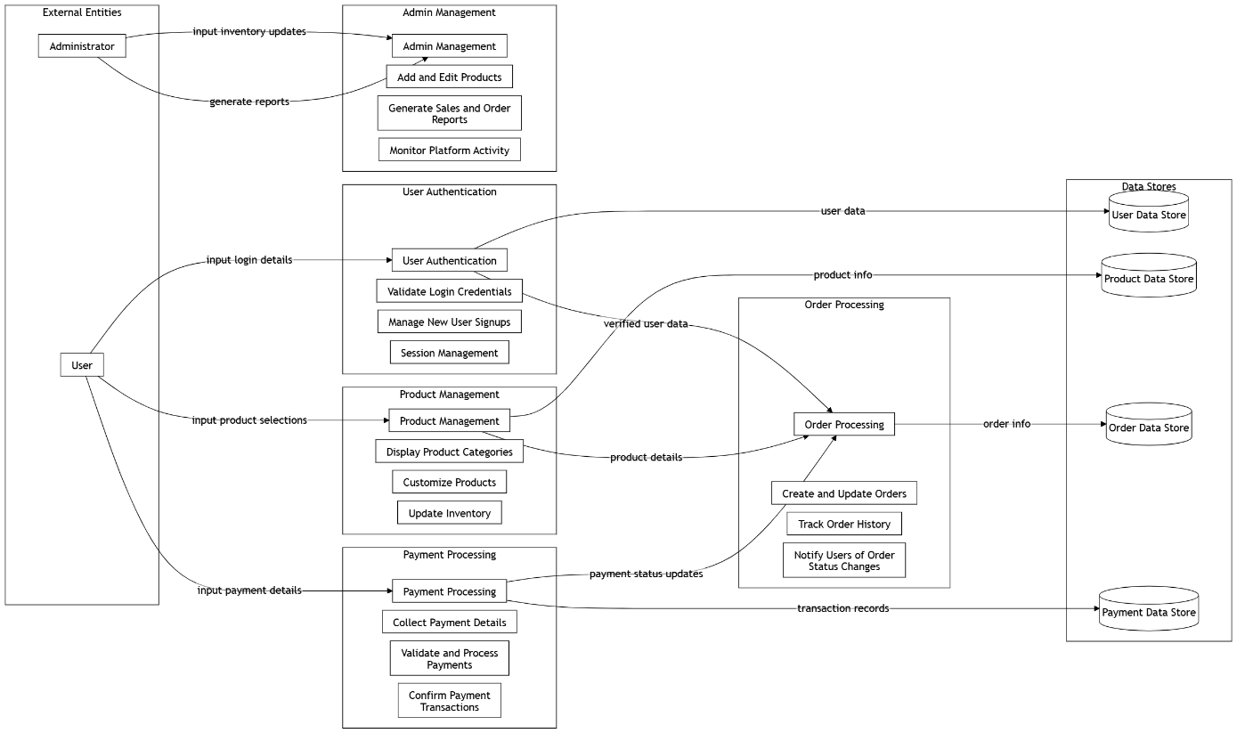

Level 2:

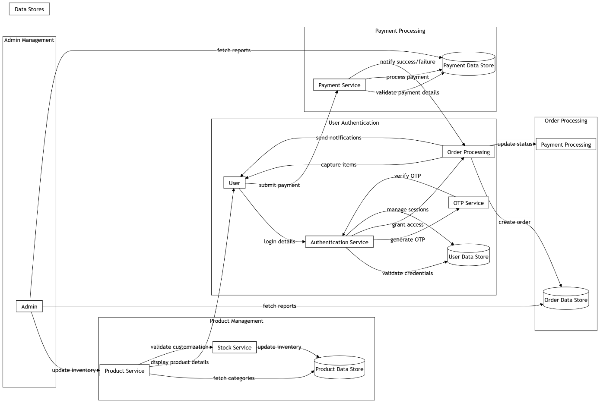

[**Entity Relationship Diagram:**](https://docs.google.com/document/d/1zWksRN2CQ0wjkqGYrrgwoKcKpXhcKkBGZMbkSeaeF8M/edit#heading=h.35nkun2)

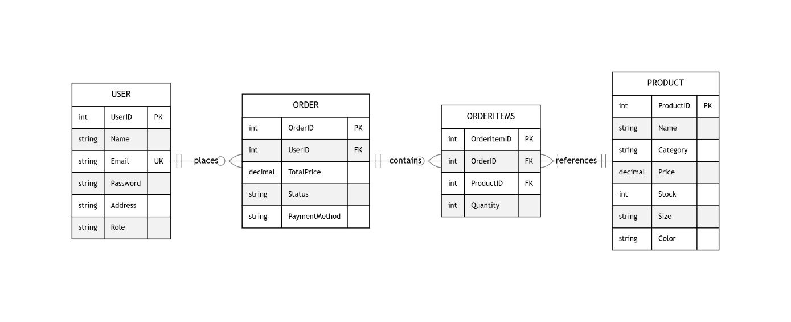

**Descriptions of Entities:**

**Entities with Attributes and Datatypes**

1. **User**
   * **UserID (Primary Key)**: SERIAL
   * **Name**: VARCHAR(100)
   * **Email**: VARCHAR(150) (Unique constraint)
   * **Password**: VARCHAR(255)
   * **Address**: TEXT
   * **Role**: VARCHAR(50) (e.g., "Admin" or "Customer")
2. **Product**
   * **ProductID (Primary Key)**: SERIAL
   * **Name**: VARCHAR(150)
   * **Category**: VARCHAR(100)
   * **Price**: DECIMAL(10, 2) (Two decimal places for monetary values)
   * **Stock**: INTEGER
   * **Size**: VARCHAR(50)
   * **Color**: VARCHAR(50)
3. **Order**
   * **OrderID (Primary Key)**: SERIAL
   * **UserID (Foreign Key)**: INTEGER (References User.UserID)
   * **TotalPrice**: DECIMAL(10, 2)
   * **Status**: VARCHAR(50) (e.g., "Active", "Completed", "Cancelled")
   * **PaymentMethod**: VARCHAR(50) (e.g., "Stripe", "Cash on Delivery")
4. **OrderItems**
   * **OrderItemID (Primary Key)**: SERIAL
   * **OrderID (Foreign Key)**: INTEGER (References Order.OrderID)
   * **ProductID (Foreign Key)**: INTEGER (References Product.ProductID)
   * **Quantity**: INTEGER

**Relationships with Cardinality**

1. **User → Order**:
   * **Relationship**: 1:N (One User places many Orders)
   * **Foreign Key**: UserID in Order table references UserID in User.
2. **Order → OrderItems**:
   * **Relationship**: 1:N (One Order contains many OrderItems)
   * **Foreign Key**: OrderID in OrderItems table references OrderID in Order.
3. **OrderItems → Product**:
   * **Relationship**: N:1 (Many OrderItems reference one Product)
   * **Foreign Key**: ProductID in OrderItems table references ProductID in Product.
4. **TESTING AND VALIDATION**

**Code Efficiency:**

* **Definition:** Code efficiency ensures that system resources such as memory, processing power, and network bandwidth are optimally used, keeping the application functional and responsive for users.
* **Why It Matters:** Efficient code improves user experience by reducing delays and improving system responsiveness, especially when handling large numbers of users or complex product interactions.

**Key Considerations:**

1. **Optimized Algorithms:** Implement efficient algorithms to reduce computational complexity, ensuring fast responses in actions like product searches and cart updates.
2. **Minimizing Redundant Code:** Use modular programming techniques such as functions, loops, and reusable components to avoid unnecessary repetition in code.
3. **Memory Management:** Proper handling of memory allocation and deallocation, particularly when dealing with large product catalogs or customer interactions.
4. **Asynchronous Operations:** Use asynchronous programming (such as async/await in JavaScript) to allow non-blocking operations, ensuring the UI remains responsive during background tasks (e.g., fetching product details).
5. **Code Minification:** Minify JavaScript, CSS, and HTML files for faster loading times and reduced bandwidth usage, improving user experience.
6. **Caching:** Implement client-side and server-side caching to store frequently accessed data, reducing redundant database calls and speeding up response times (e.g., caching product data, user profiles).

**Testing Approach:**

Testing is essential to ensure that the system functions as expected and meets user requirements. For **Decor Heaven**, the testing approach includes:

**Key Steps:**

1. **Test Planning:** Identify test scope, objectives, and required testing types (e.g., functional, performance, security).
2. **Test Case Design:** Design detailed test cases covering common user scenarios such as product browsing, cart updates, and order checkout.
3. **Automated Testing:** Implement automated testing for key features, including login, payment gateway integration, and product selection.
4. **Manual Testing:** Conduct manual tests for the UI/UX, especially during product customization, checkout, and profile management.
5. **Test Execution and Reporting:** Execute test cases, track results, document bugs, and provide actionable feedback for developers.
6. **User Acceptance Testing (UAT):** Engage real users to verify that the system aligns with user expectations before going live.

**Unit Testing:**

Unit testing verifies individual components of the system to ensure each part works correctly before integration.

**Areas to Test:**

1. **User Authentication:** Test the login functionality, including email/password and Google Sign-In methods.
2. **Product Customization:** Ensure that selecting product size, color, and other customizations works as expected.
3. **Shopping Cart Logic:** Validate the process of adding items to the cart, updating quantities, and removing products.
4. **Order Processing:** Ensure that the checkout process, including payment processing (Stripe), completes successfully.
5. **Profile Management:** Test the update functionality for user profiles, such as address and payment details.

**Tools for Unit Testing:**

* **Jest:** For testing React components and frontend logic.
* **Mocha/Chai:** For testing backend services, such as user authentication and product management.
* **Supertest:** For testing API endpoints like product retrieval, cart actions, and payment requests.

**Integration Testing:**

Integration testing ensures that different components of the system interact smoothly and data flows correctly between them.

**Key Areas to Test:**

1. **Frontend and Backend Communication:** Validate proper data exchange between React frontend and Spring Boot backend.
2. **Authentication Integration:** Test the login and signup process, ensuring credentials are correctly validated and stored.
3. **Product and Cart Integration:** Ensure that when a product is added to the cart, it appears with the correct details and pricing.
4. **Payment Gateway Integration:** Verify that the Stripe integration processes payments correctly and updates order status.
5. **Database Integration:** Ensure that data changes (e.g., product updates, order creation) are correctly reflected in the PostgreSQL database.

**Tools for Integration Testing:**

* **Jest:** Can be used for integration testing of backend logic and frontend components.
* **Postman:** Useful for testing API endpoints, such as login, product listing, and order creation.
* **Supertest:** Useful for testing API routes and data flow across the system.

**5.USER MANUAL**

The **User Manual** provides step-by-step instructions for users interacting with **Decor Heaven**, helping them navigate the site and perform actions such as browsing products, customizing orders, and making purchases.

**1. Accessing the Website:**

* **Step 1**: Open a web browser (e.g., Chrome, Firefox, Safari).
* **Step 2**: Type the website URL and press **Enter**.
* **Step 3**: Once the homepage loads, you can navigate through sections such as:
  + **Shop Furniture**
  + **View New Arrivals**
  + **Search Products**
  + **View Promotions**

**2. Signing Up and Logging In:**

* **Step 1**: To sign up, click on **"Sign Up"** on the homepage.
* **Step 2**: Choose to sign up with **Google Sign-In** or by entering an **email and password**.
* **Step 3**: For first-time users, an OTP will be sent for **Multi-Factor Authentication (MFA)**. Enter the OTP to complete the signup.
* **Step 4**: To log in, click **"Log In"** and enter your credentials or use **Google Sign-In**.

**3. Browsing and Customizing Products:**

* **Step 1**: From the homepage, browse through product categories such as **Furniture** and **Interiors**.
* **Step 2**: Select a product to view details.
* **Step 3**: Choose product customizations like **size** and **color**.
* **Step 4**: If desired, view **similar products** that may also interest you.
* **Step 5**: Once you've selected your customizations, click **"Add to Cart"**.

**4. Shopping Cart and Checkout:**

* **Step 1**: To view your cart, click on the **"Cart"** icon in the header.
* **Step 2**: Review the products in your cart. You can **update quantities** or **remove items** as needed.
* **Step 3**: When ready, click **"Proceed to Checkout"**.
* **Step 4**: Choose your **payment method** (Credit/Debit Card or Cash on Delivery).
* **Step 5**: Complete the payment process using **Stripe**.

**5. Profile Management:**

* **Step 1**: After logging in, navigate to **Profile** from the menu.
* **Step 2**: Here, you can update your **name**, **address**, and **payment details**.
* **Step 3**: You can also view your **order history**, including active, completed, and canceled orders.

**6. Order Tracking:**

* **Step 1**: Once an order is placed, go to **"Orders"** in your profile.
* **Step 2**: You can view the status of your order: **active**, **completed**, or **canceled**.
* **Step 3**: Track the shipping status of your orders, if available.

**7. Contact Support:**

* **Step 1**: If you need assistance, click **"Contact Support"** from the website footer.
* **Step 2**: Choose your preferred method of contact: **Live Chat**, **Email**, or **Phone**.
* **Step 3**: Provide details about your issue or inquiry to get the support you need.

**User Documentation:**

This section explains the core features and functionality of **Decor Heaven** and how users can interact with it.

**1. Product Customization:**

Allows users to customize products before purchasing.

* **How to Use:**
  + Select a product.
  + Choose size, color, and other customization options.
  + Review and add the product to the cart.

**2. Shopping Cart:**

The shopping cart stores selected products until checkout.

* **How to Use:**
  + Add products to your cart from the product details page.
  + Review, update, or remove items before proceeding to checkout.

**3. Order Processing:**

Track and manage your orders after purchase.

* **How to Use:**
  + View your order status in the **Profile** section.
  + Follow up on order delivery or cancellations.

**4. Payment System (Stripe):**

Provides a secure payment gateway for completing orders.

* **How to Use:**
  + Choose payment options during checkout.
  + Enter payment details for processing through Stripe.

**5. Feedback and Suggestions:**

Submit feedback about your experience to improve the platform.

* **How to Use:**
  + Navigate to the **Feedback** section and fill out the form.
  + Provide suggestions or report issues.

**Output:**

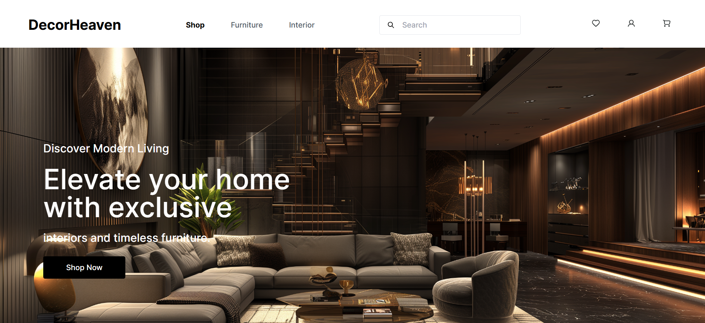

## 9.1 Home Page

The homepage of the **Decor Heaven** website presents users with a sleek and intuitive navigation menu, offering seamless access to essential sections such as New Arrivals, Furniture, Interiors, and personalized recommendations. Through captivating visuals and concise messaging, the homepage effectively conveys the platform's mission to provide high-quality furniture and interior solutions. It highlights key features, such as product customization options and exclusive collections, inviting visitors to explore and engage with the platform's offerings. Additionally, prominently displayed design tips and trends offer valuable insights and inspiration to users, enhancing their interior design experience and empowering them to create beautiful spaces.

## 9.2 Furniture Section

The **Furniture Section** of the **Decor Heaven** website offers users a tailored browsing experience with powerful filters for price, size, color, and categories. Customers can seamlessly explore an extensive collection of high-quality furniture pieces, ranging from sofas and beds to dining tables and chairs. The intuitive filter system allows users to refine their search and find products that perfectly match their preferences and needs. With visually appealing layouts and detailed product descriptions, this section ensures a smooth and enjoyable shopping journey for users looking to enhance their living spaces with functional and stylish furniture.

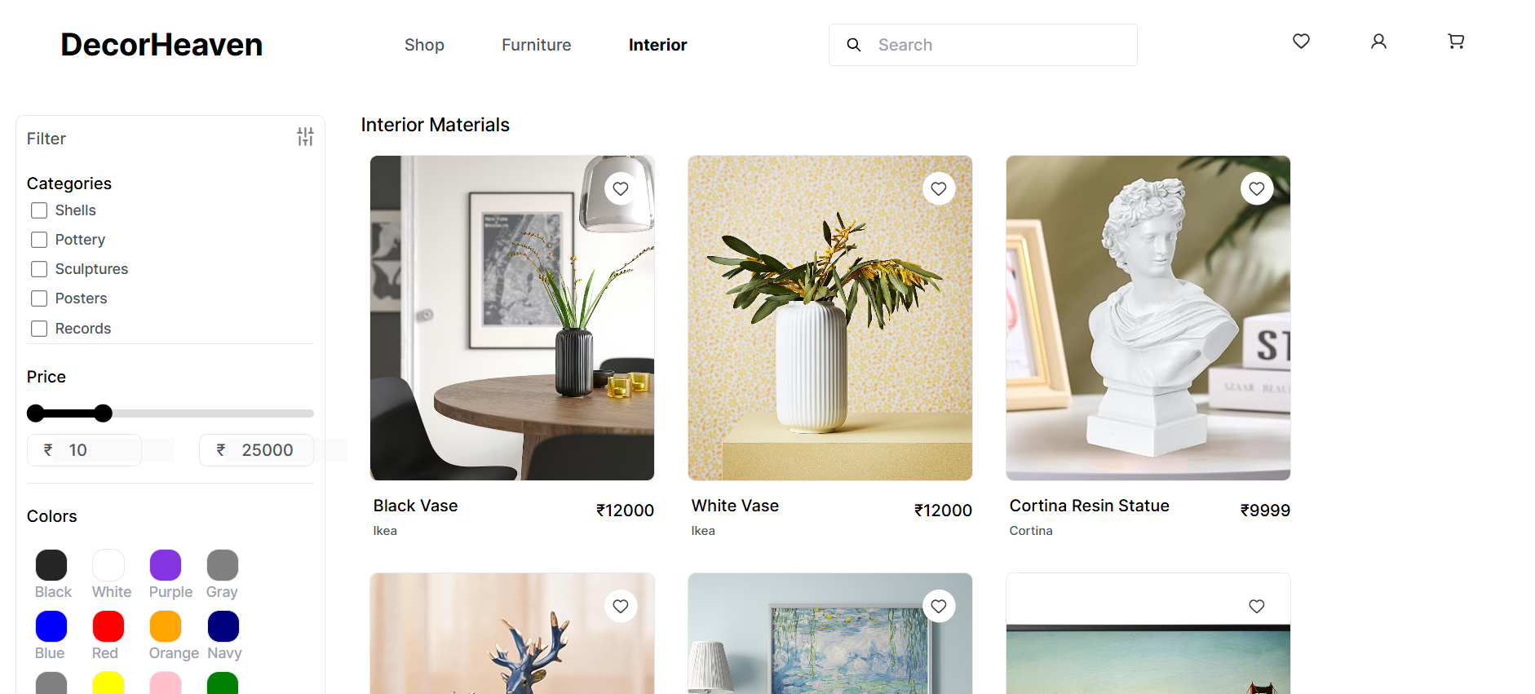 **9.2.1 Interior Section**

The **Interior Section** of the **Decor Heaven** website provides users with a curated selection of décor items, lighting solutions, rugs, and more to complement any space. Equipped with advanced filters for price, color, material, and style categories, this section simplifies the process of finding the perfect interior elements to complete a room’s aesthetic. Through an elegant and user-friendly interface, the platform offers inspiration and convenience, empowering users to bring their design visions to life with décor options that reflect their unique tastes.

## 9.3 Product Page

Located conveniently in the center of the product page, the high-resolution product image on the Decor Heaven website provides users with a detailed view of the selected item. By exploring the image and additional thumbnails, users can examine the design, texture, and aesthetics from various angles, enhancing their confidence and decision-making while purchasing furniture or interior products.

### 9.3.1 Cart Section

Upon clicking the "Add to Cart" button on the Decor Heaven product page, users are redirected to the "Shopping Bag" section. This page provides a clear overview of the selected items, including product details such as the name, size, color, price, and quantity. Users can conveniently adjust the quantity or remove items from the cart.

A section for applying discount coupons is also prominently displayed, allowing users to enter their coupon code for potential savings. The page clearly displays a breakdown of the subtotal, shipping charges (if any), and the grand total, enhancing transparency. Finally, users are provided with a "Login to Checkout" button, which guides them seamlessly to the secure checkout process to complete their purchase.

### 9.3.2 Payment Sectiom

Upon proceeding to the checkout on Decor Heaven, users are directed to a detailed and user-friendly interface where they can finalize their purchase. The page displays the delivery address, ensuring accuracy and allowing for any necessary edits. Users are prompted to select a preferred delivery date, with options clearly outlined for convenience.

The payment section offers multiple methods, including Credit/Debit Card, Cash on Delivery, and UPI/Wallet, ensuring flexibility for all user preferences. For card payments, users are required to input their card details (card number, expiration date, and CVV) securely. Once entered, they can finalize the transaction by clicking the "Pay Now" button. The integration with Stripe ensures a secure and seamless payment process.

Additionally, a summary of the order, including item count, subtotal, shipping charges (if any), and the total payable amount, is prominently displayed for transparency. This layout ensures a smooth and confident checkout experience for users.

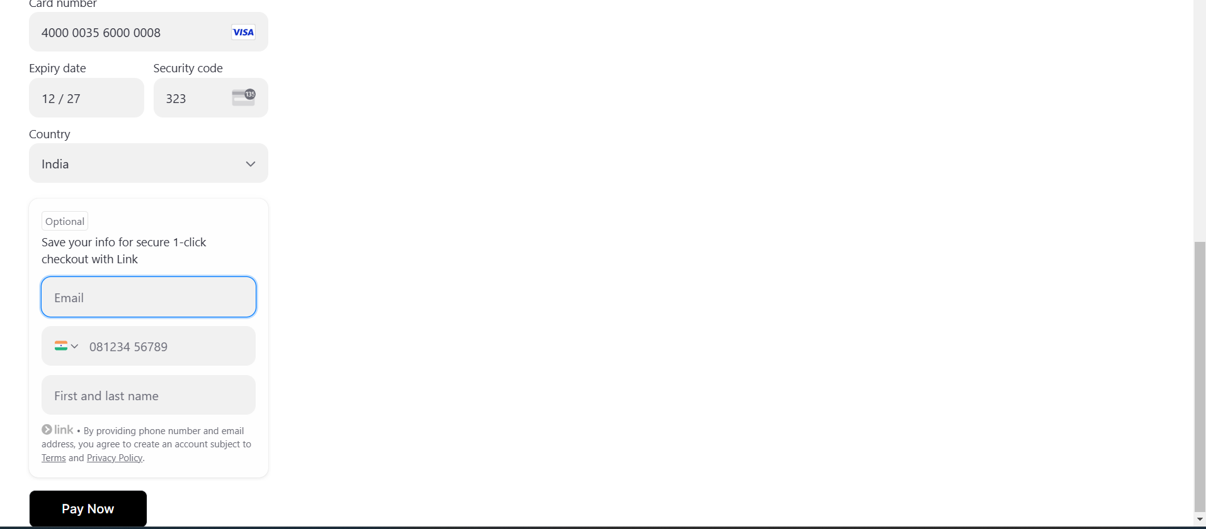

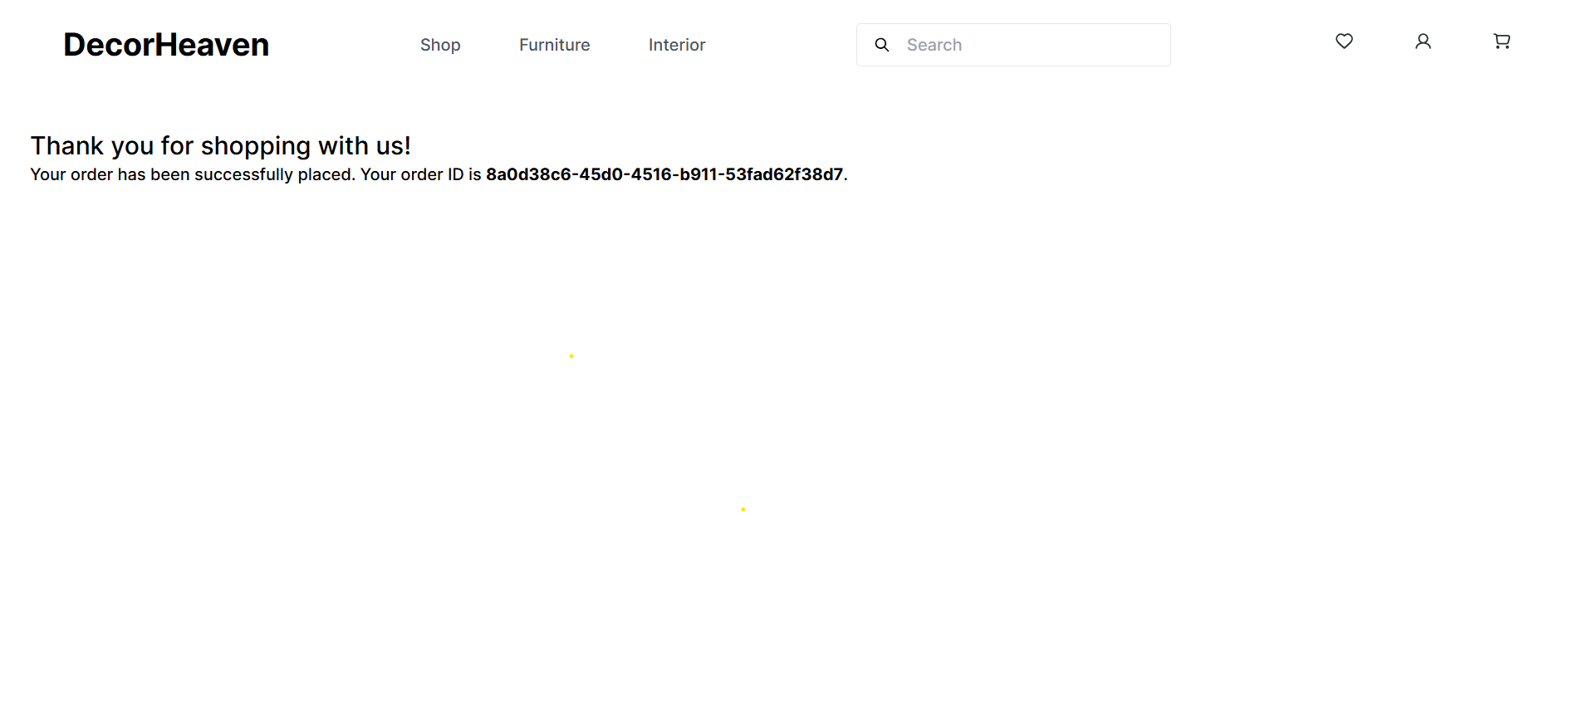

### 9.3.3 Orders Section

After completing the payment process, users can click on profile section where they get redirected to the **Order Page**, where they can efficiently manage their orders. This page provides a comprehensive overview, including:

* **Active Orders**: Displays orders currently in process, along with their status and estimated delivery date.
* **Cancelled Orders**: Lists orders that have been cancelled by the user or due to other reasons.
* **Delivered Orders**: Shows details of successfully delivered products, including delivery dates and order summaries.

Each order comes with detailed information such as the product name, quantity, price, and delivery status. Additionally, users have the option to **cancel active orders** directly from this page if the cancellation window is still open. This feature ensures flexibility and control, empowering users to manage their orders seamlessly.

### 9.3.4 Cancel Order

This page displays all the previous order which are cancelled in detail with their product images and more details also display the quantity and price and they due date on which the project was going to be delivered.

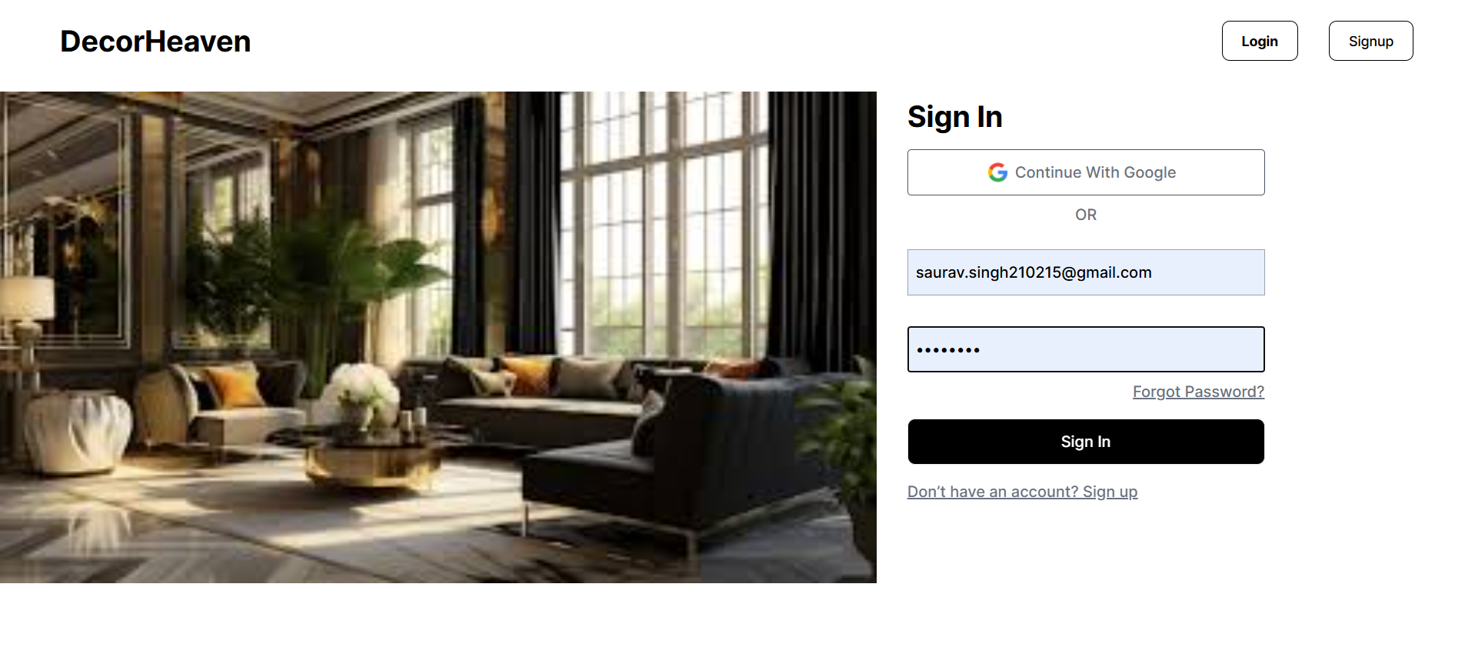

## 9.4 Login Page

The Feedback Submission page of the Cybercrime Solution website presents users with a simple and intuitive interface to submit their feedback. Users can enter their name, email address, and subject, providing a seamless way to share their thoughts and suggestions with the website administrators. This streamlined process ensures efficient communication and fosters user engagement, contributing to the continuous improvement of the website's features and services.

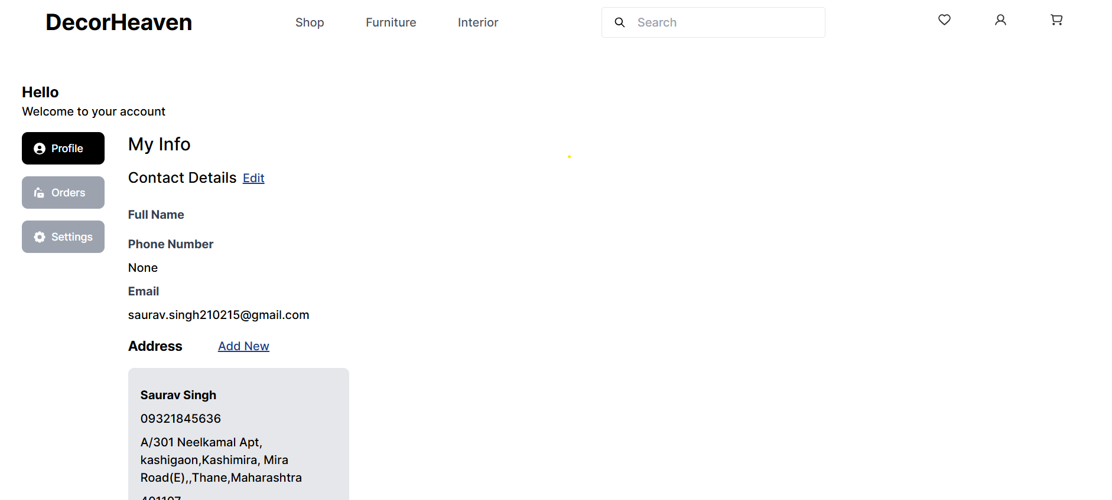

### 9.4.1 Profile Page

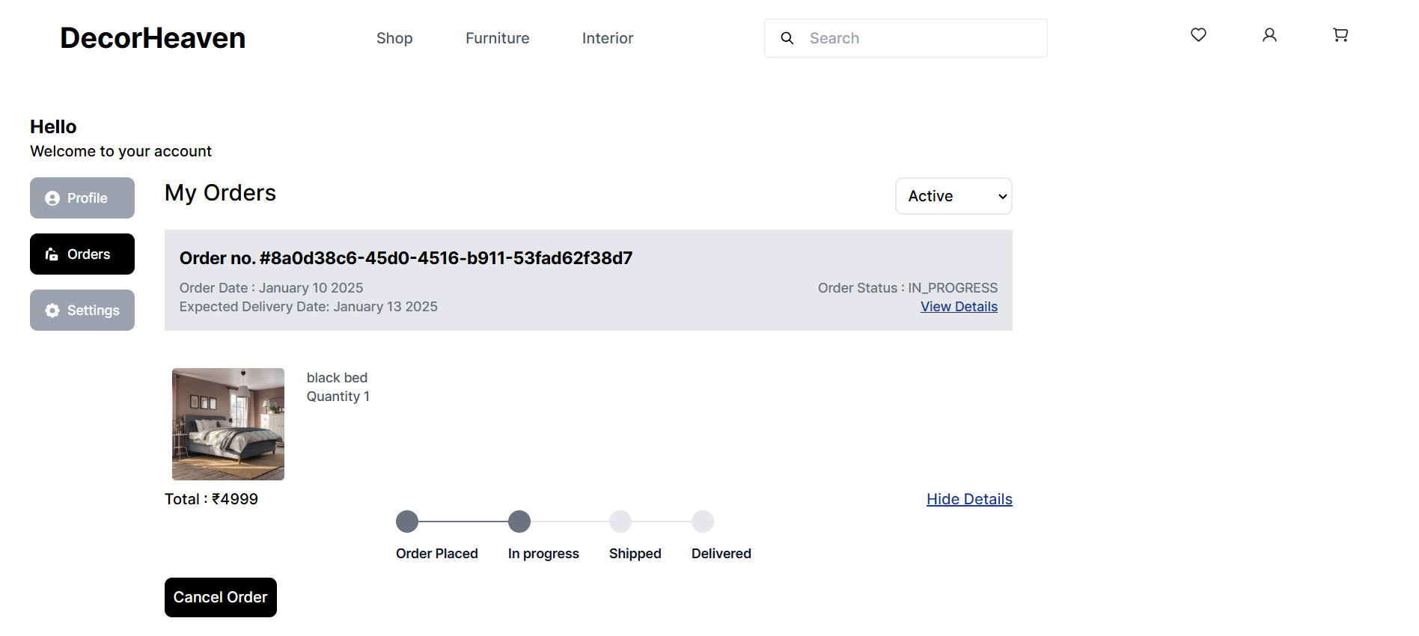

### 9.4.2 Order Page

## 9.5 New Arrival

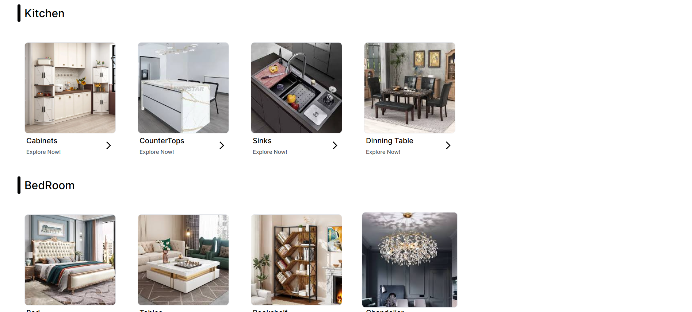

## 9.6 Database Storage

The database storage screenshot showcases the data stored in **pgAdmin PostgreSQL**, the backend database utilized by the DecorHeaven website. This snapshot highlights the structured organization of various tables, including those for **auth users, user details, products and their details, payment information, categories, and user accounts**. By leveraging PostgreSQL's robust data storage and retrieval mechanisms, DecorHeaven ensures secure and efficient management of data, facilitating seamless functionality and enabling comprehensive analysis to drive continuous improvements.

## 9.7 About Us

The About Us page of the DecorHeaven website offers a concise overview of the platform's mission, vision, and objectives. Through informative content and engaging visuals, users gain insight into the website's purpose and commitment to revolutionizing furniture and interior design. This section encapsulates the essence of DecorHeaven's identity and its dedication to creating beautiful, functional, and personalized spaces for its customers.

**Code Snippets:**

**Shop.js**

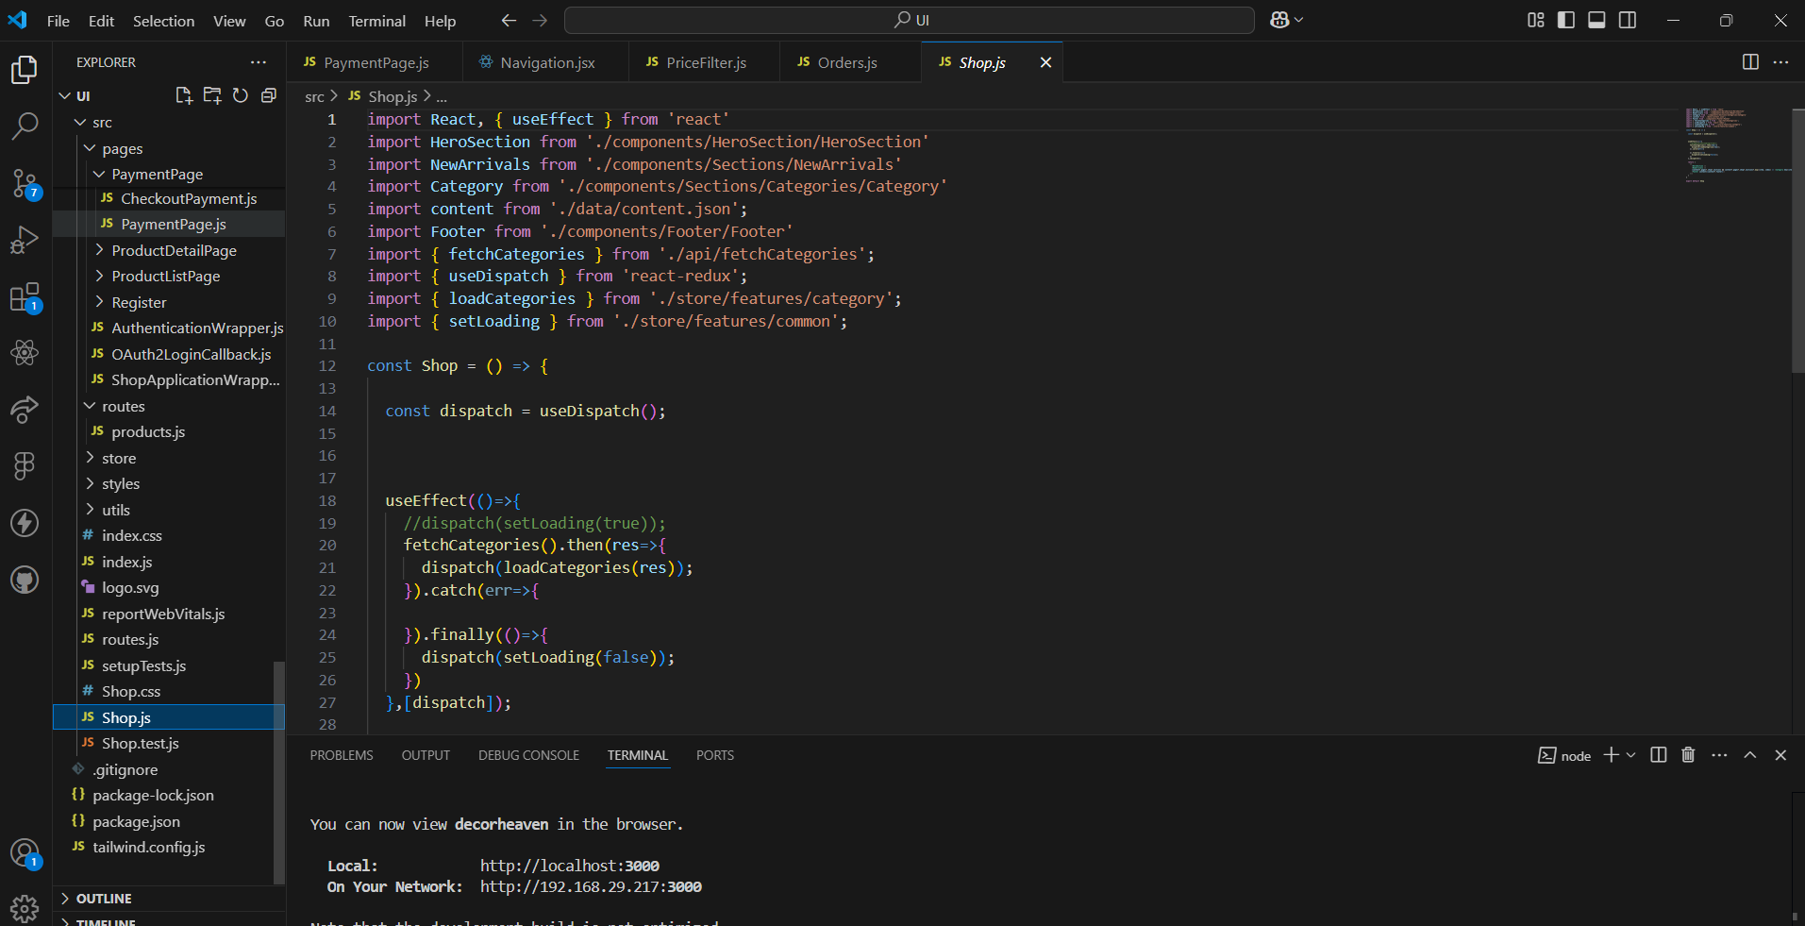

**Navigation.jsx**

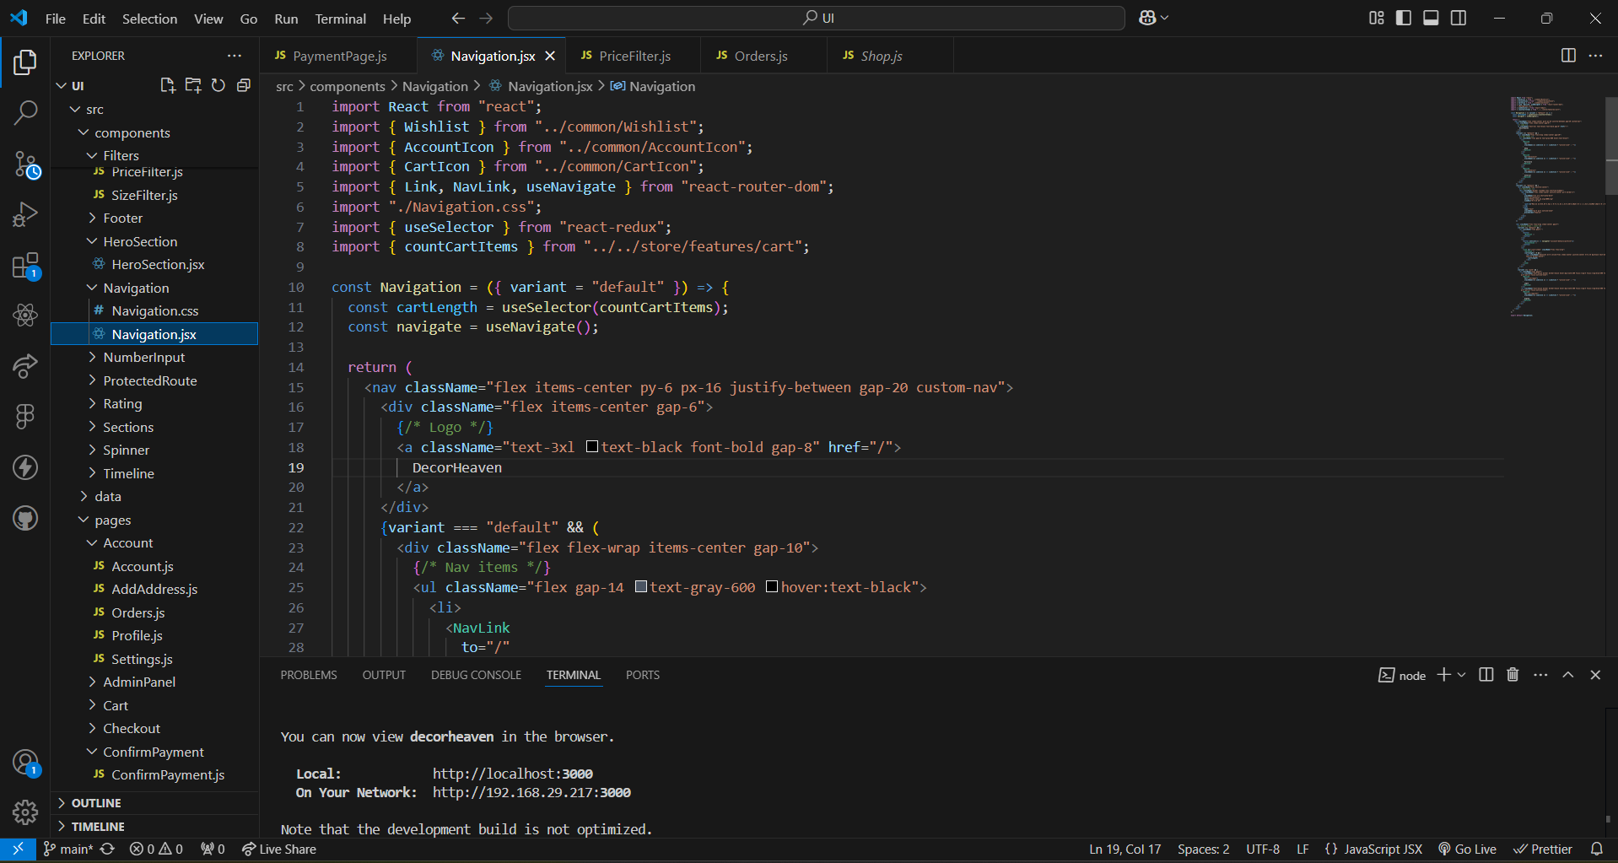

**Content.json**

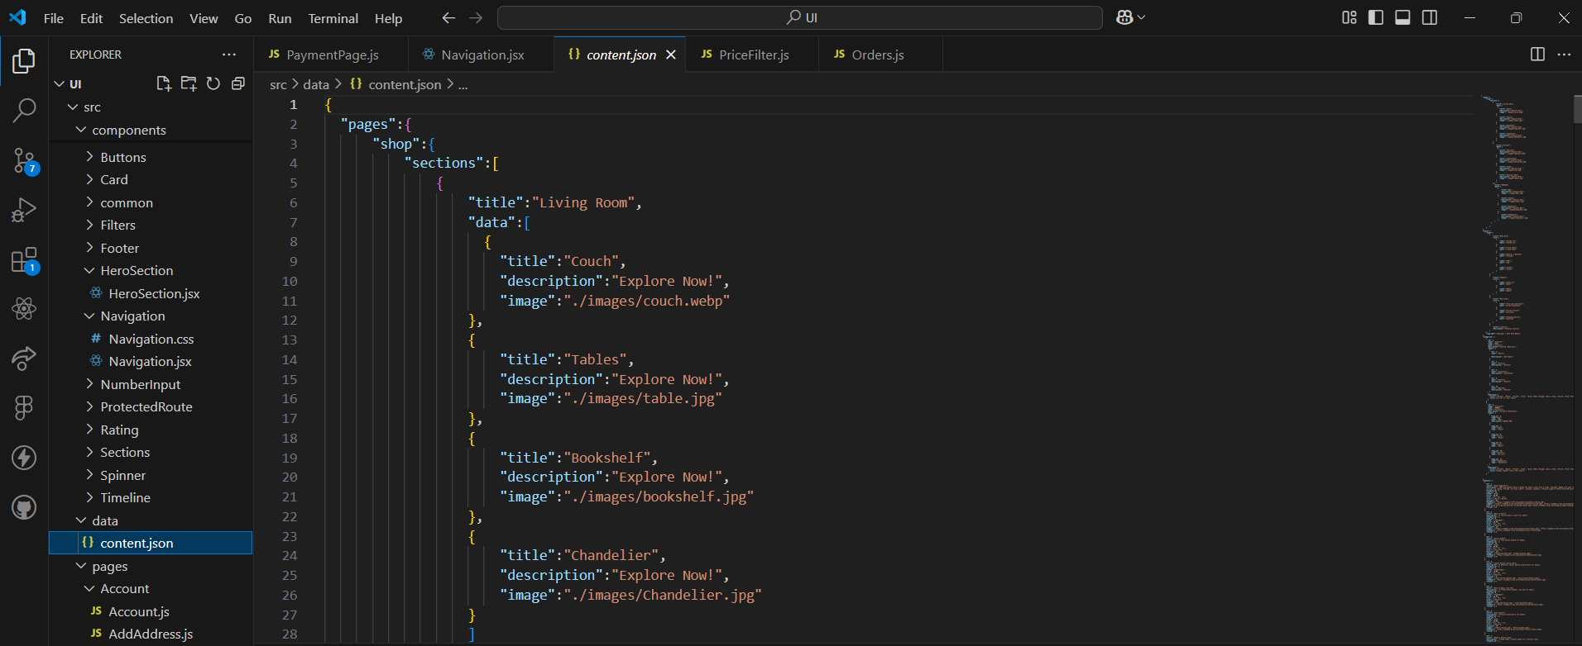

**index.js**

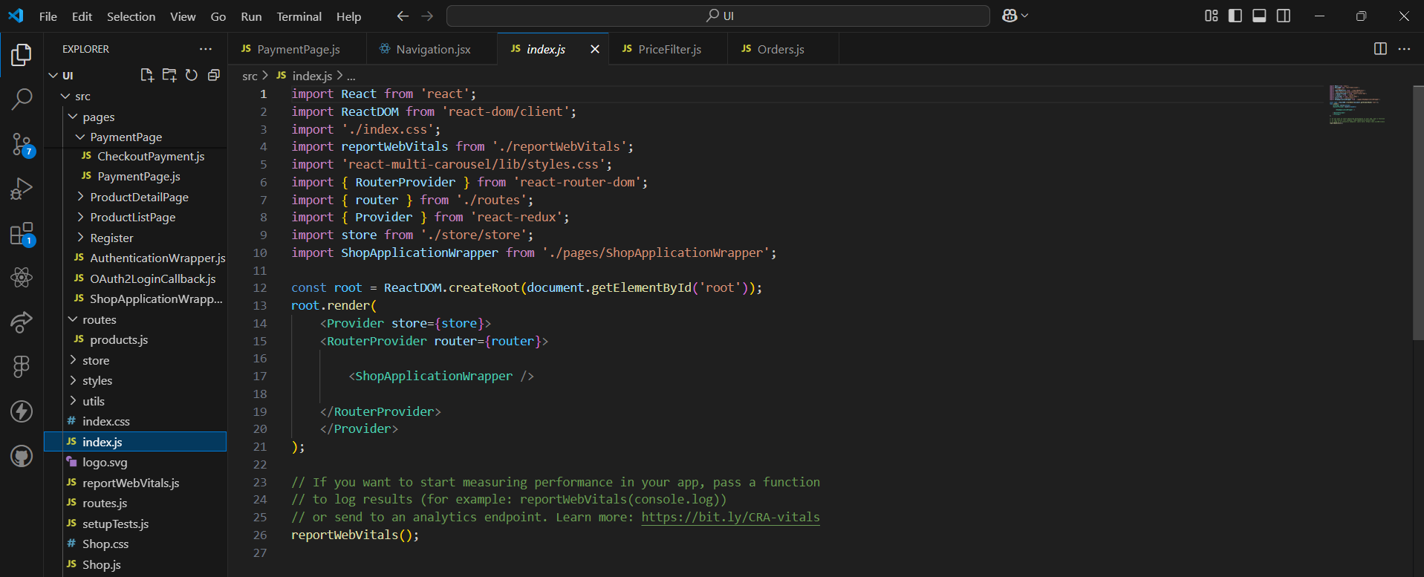

**Filestructure:**

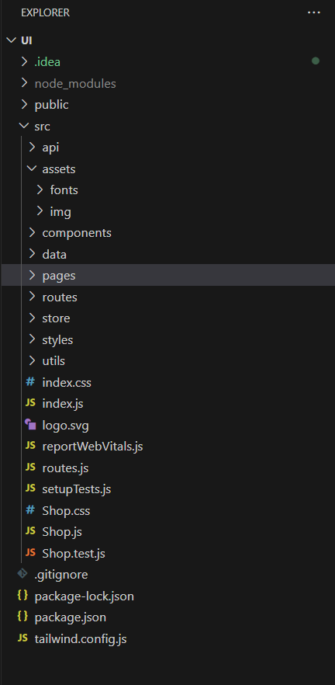

# 6. CONCLUSION

**Conclusion:**

**Decor Heaven** has emerged as a premier online platform for furniture and interior design, revolutionizing how customers approach home decor by providing a seamless and personalized shopping experience. With its user-friendly interface, advanced features, and vast collection of customizable products, the platform has successfully bridged the gap between modern e-commerce and interior design solutions. From offering furniture customization to supporting easy checkout through secure payment gateways, **Decor Heaven** has prioritized customer satisfaction and convenience, creating an engaging and reliable shopping environment.

The website's integration of cutting-edge technologies, such as React, Tailwind CSS, and Spring Boot, has ensured a smooth and dynamic user experience while maintaining performance across different devices. Through continuous development and a focus on innovation, **Decor Heaven** remains committed to meeting the evolving needs of customers, delivering high-quality products and exceptional service.

As **Decor Heaven** continues to grow, it is poised to reshape the future of online furniture shopping, allowing customers to express their individual styles through curated collections and personalized experiences. Moving forward, the platform will strive to expand its market reach and enhance user engagement, setting a new standard for e-commerce platforms in the interior decor industry.

**Limitations:**

1. **Limited Geographic Reach:** Despite plans for expansion, **Decor Heaven** may face challenges in reaching remote or underserved regions, where delivery logistics and internet access may be limited.
2. **Language and Localization Barriers:** While **Decor Heaven** supports multiple languages, it may not yet cover all global regions or languages, potentially limiting access for users in certain linguistic communities.
3. **Digital Divide:** Socioeconomic disparities could restrict access to **Decor Heaven**'s services, especially for customers in regions with limited digital literacy or access to modern internet-enabled devices.
4. **Dependence on Internet Connectivity:** The performance and availability of **Decor Heaven** rely heavily on internet connectivity, which could be an issue in areas with unstable internet connections.
5. **Resource Constraints:** Financial or operational limitations may hinder the speed at which new features or regional expansions can be implemented, potentially limiting growth opportunities.
6. **Legal and Compliance Issues:** Navigating varying regional e-commerce laws, such as data protection regulations, might challenge the platform’s ability to expand across jurisdictions without adjusting business practices.
7. **Cybersecurity Risks:** As an e-commerce platform, **Decor Heaven** is a target for potential cyber threats such as data breaches or malware attacks, necessitating continuous monitoring and robust security measures.

**Future Scope:**

**Emerging Technologies:**

To stay at the forefront of the online shopping experience, **Decor Heaven** plans to integrate several innovative technologies:

1. **AI and Machine Learning:** For personalized product recommendations, smart search features, and dynamic inventory management.
2. **Augmented Reality (AR):** Enabling customers to visualize furniture and home decor items in their spaces, helping with better decision-making before purchasing.
3. **Virtual Reality (VR):** Offering immersive experiences for users to explore entire room designs and decor options in 3D.
4. **IoT Integration:** Allowing smart furniture that can be controlled through the app, enhancing convenience and modern living solutions.
5. **Blockchain:** For ensuring transparent and secure payment processes, particularly for cross-border transactions.

**Scalability Strategies:**

To accommodate increased user activity and future growth, **Decor Heaven** employs the following strategies:

1. **Cloud Infrastructure:** Leveraging scalable solutions like AWS or Google Cloud to manage increased traffic and resource demands.
2. **Microservices Architecture:** Breaking down the platform into smaller, independent services to ensure modular scaling as needed.
3. **Load Balancing:** Using load balancing technologies to distribute user traffic evenly across servers, ensuring optimal performance even during peak hours.
4. **Database Sharding:** Splitting large databases into smaller, more manageable parts to improve system performance and reduce latency.
5. **Caching and CDN:** Implementing caching mechanisms and Content Delivery Networks (CDN) for faster access to static resources, thus improving the overall user experience.

**Global Expansion Plans:**

As **Decor Heaven** looks to grow globally, the platform will focus on:

1. **Localization:** Adapting product listings, user interfaces, and marketing materials to cater to regional preferences, languages, and cultural nuances.
2. **International Partnerships:** Collaborating with local vendors and logistics companies to improve supply chain efficiency and meet demand in different regions.
3. **Targeted Awareness Campaigns:** Promoting **Decor Heaven**'s brand and cybersecurity protocols to ensure safe shopping practices in new markets.
4. **Training and Support Programs:** Offering region-specific customer service and training programs to better assist users from various parts of the world.
5. **Staying Innovative:** Continuously adapting to global e-commerce trends and technological advancements to provide the best user experience and high-quality products.